**Practical 1**

**Aim:** Print only the words that start with letter ‘s’ in the following statement-St-‘print only the word that starts with s in this sentence’.

**Code:**

string= -‘print only the word that starts with s in this sentence’.

for word in string.split():

if word.startswith(‘s’):

print(word)

**Output:**

starts

s

sentence

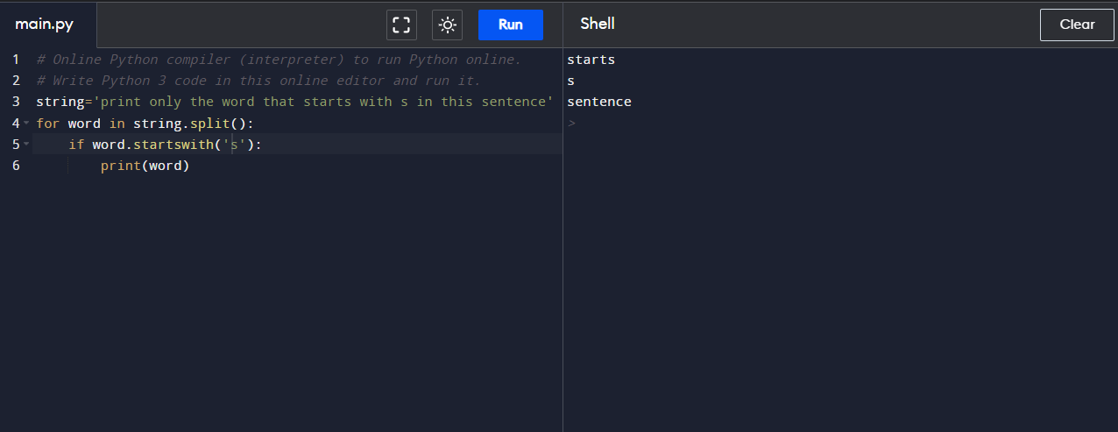

**Practical 2**

**Aim:** Print every word from the below sentence which has even number of letters –St-‘print only the word that starts with s in this sentence’

**Code:**

string='print only the word that starts with s in this sentence'

s=string.split(" ")

for word in s:

if len(word)%2 == 0:

print(word)

**Output:**

only

word

that

starts

with

in

this

sentence

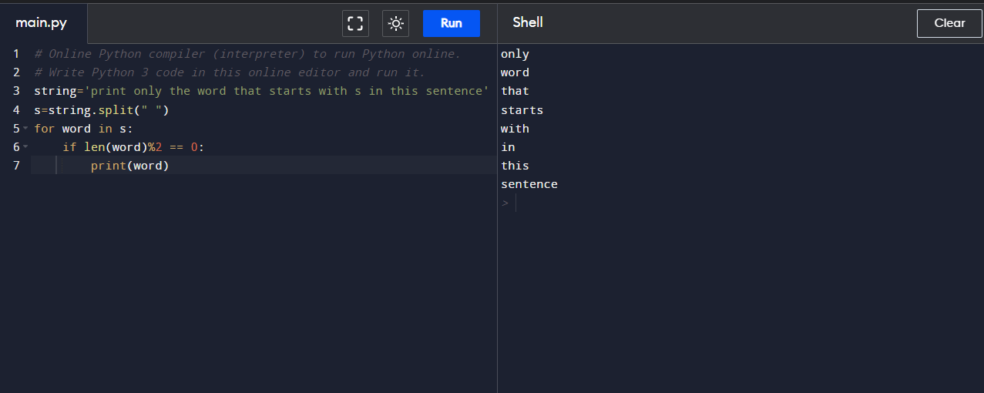

**Practical 3**

**Aim:** Write a program that prints the integers from 1 to 100, but for multiples of 3 prints “FIZZ” instead of number and prints “BUZZ” for multiples of 5. For multiples of both 3 and 5 it must print “FIZZBUZZ”.

**Code:**

for n in range (1,101):

if n%3==0 and n%5==0:

print("FIZZBUZZ")

elif n%3==0:

print("FIZZ")

elif n%5==0:

print("BUZZ")

else:

print(n)

n=n+1;

**Output:**

1

2

**FIZZ**

4

**BUZZ**

**FIZZ**

7

8

**FIZZ**

**BUZZ**

11

**FIZZ**

13

14

**FIZZBUZZ**

16

17

FIZZ

19

**BUZZ**

**FIZZ**

22

23

**FIZZ**

**BUZZ**

26

FIZZ

28

29

**FIZZBUZZ**

31

32

**FIZZ**

34

**BUZZ**

**FIZZ**

37

38

**FIZZ**

**BUZZ**

41

**FIZZ**

43

44

**FIZZBUZZ**

46

47

**FIZZ**

49

**BUZZ**

**FIZZ**

52

53

**FIZZ**

**BUZZ**

56

**FIZZ**

58

59

**FIZZBUZZ**

61

62

**FIZZ**

64

**BUZZ**

**FIZZ**

67

68

**FIZZ**

**BUZZ**

71

FIZZ

73

74

**FIZZBUZZ**

76

77

**FIZZ**

79

**BUZZ**

**FIZZ**

82

83

**FIZZ**

**BUZZ**

86

FIZZ

88

89

**FIZZBUZZ**

91

92

**FIZZ**

94

**BUZZ**

**FIZZ**

97

98

**FIZZ**

**BUZZ**

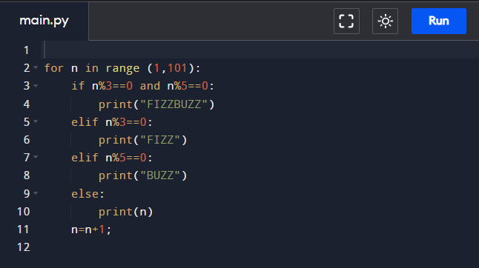

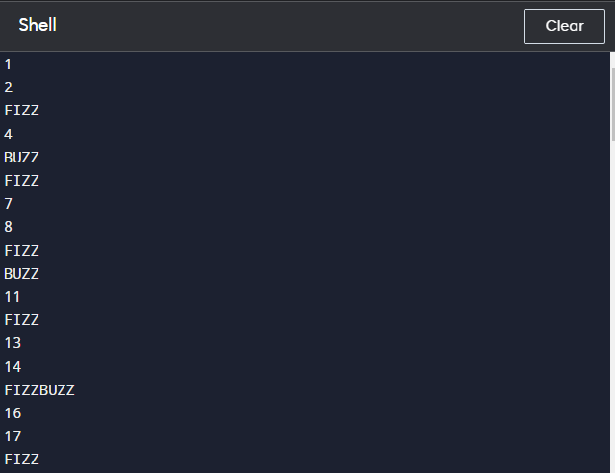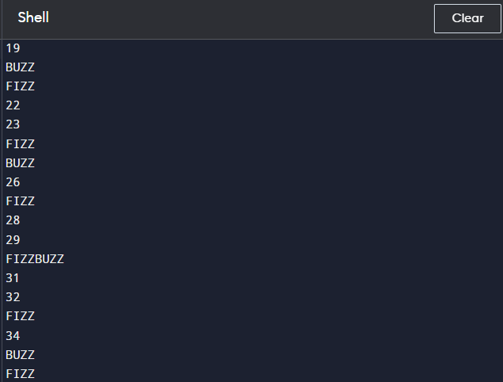

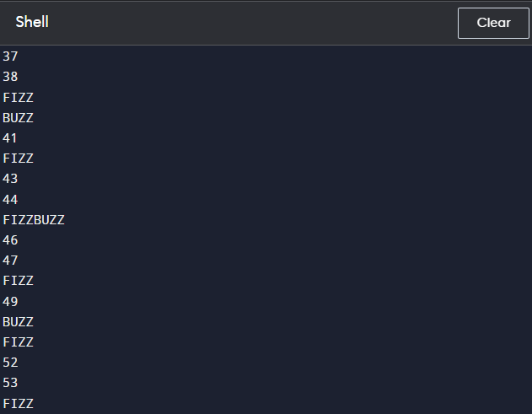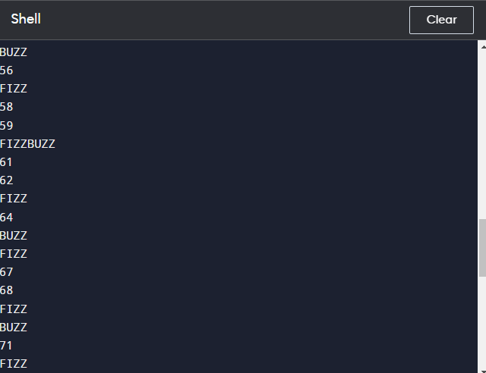

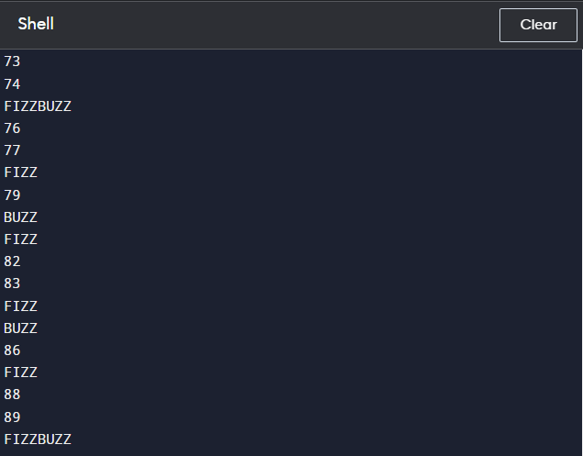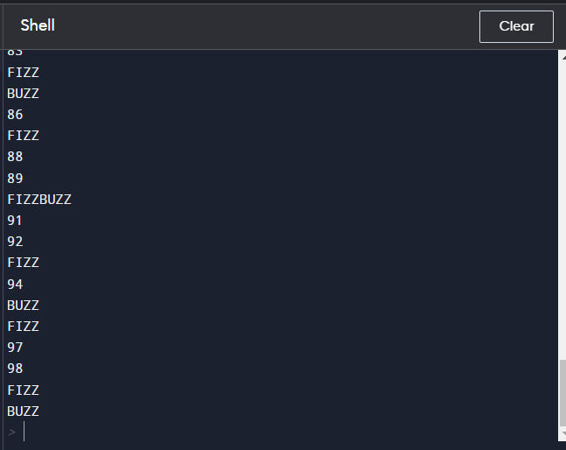

**Practical 4**

**Aim:** Write a program using function to check who is employee of the month.

**Theory:**

**Function:** Python Functions is a block of statements that return the specific task. The idea is to put some commonly or repeatedly done tasks together and make a function so that instead of writing the same code again and again for different inputs, we can do the function calls to reuse code contained in it over and over again.

Syntax:

**def**(keyword**) fun_name**(name of the function**)(parameters if any):**

**#code**

**return statement**

Types of Functions in Python:

There are mainly two types of functions in Python.

● **Built-in library function:** These are standard functions in Python that are available to use.

● **User-defined function:** We can create our own functions based on our requirements. In the given below program, the function takes a dictionary of employees as input and returns the employee of the month. The employee of the month is the one with the highest number of hours worked in the month.

Here in this example, we are deciding the ‘Employee of the month’ simply on the basis of hours worked by that particular employee.

**Code:**

def get_employee_of_the_month(employees):

employee_of_the_month = ""

max_hours = 0

for employee, hours in employees.items():

if hours > max_hours:

max_hours = hours

employee_of_the_month = employee

return employee_of_the_month

employees = {"Ajay": 160, "Sanjay": 200, "Vikram": 280, "Rahul": 190 , "Mahesh" : 195}

employee_of_the_month = get_employee_of_the_month(employees)

print("The employee of the month is {employee_of_the_month}.")

**Output:**

The employee of the month is Vikram.

**Practical 6**

**Aim:** Write a program that returns the lesser of two given numbers if both numbers are even, but returns the greater if one or both numbers are odd.

**Code:**

x=int(input('Enter your first number:'))

y=int(input('Now enter the second one:'))

if(x%2!=0 or y%2!=0):

if(x>y):

print("greater number:",x)

elif(y>x):

print("greater number:",y)

else:

print("both are same!")

elif(x%2==0 and y%2==0):

if(x<y):

print("smaller number:",x)

elif(y<x):

print("smaller number:",y)

else:

print("both are same!")

**Output:**

Enter your first number: 66

Now enter the second one: 77

Greater number: 77

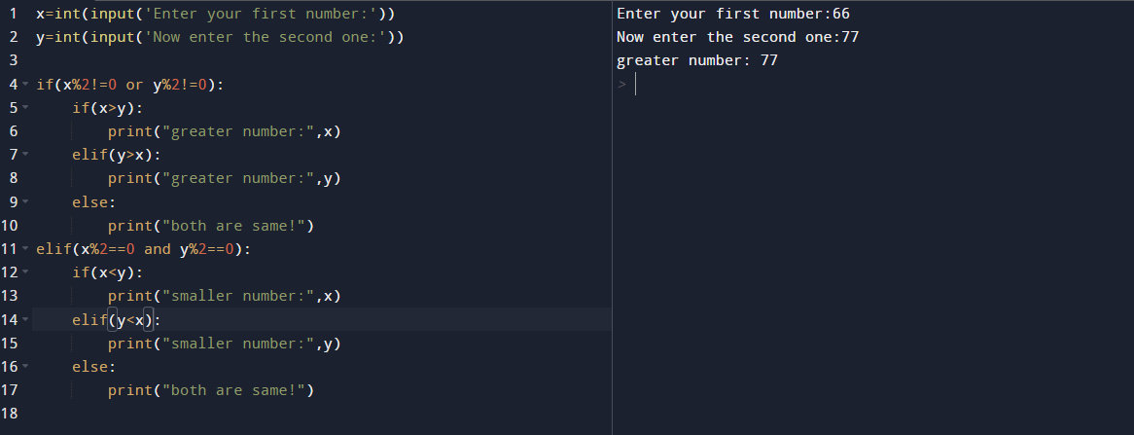

**Practical 7**

**Aim:** Write a python function that accepts a string and calculate the number of upper case letters and lower case letters.

**Output:** Original String : The quick Brown Fox

No. of Upper case characters :3

No. of Lower case characters :13

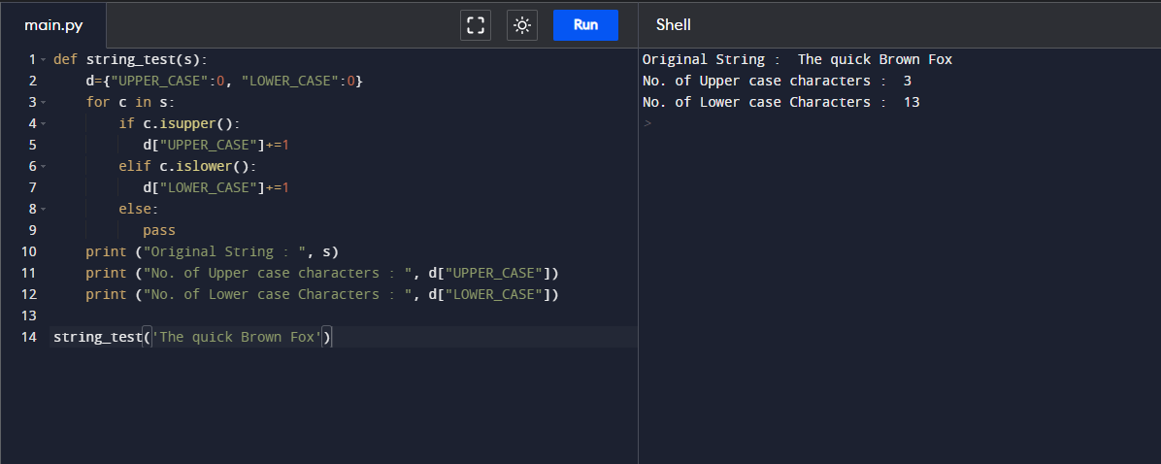

string='Hello Worlds'

n=0

m=0

for x in string:

if x.isupper():

n=n+1

else:

m=m+1

print("n=",n)

print("m=",m)

**Practical 8**

**Aim:** Write a python function that takes a list and return a new list with unique elements of the first list. For example, Sample List =[1,1,1,2,2,3,3,4]Unique List = [1,2,3,4]

**Output:** [1, 2, 3, 4]

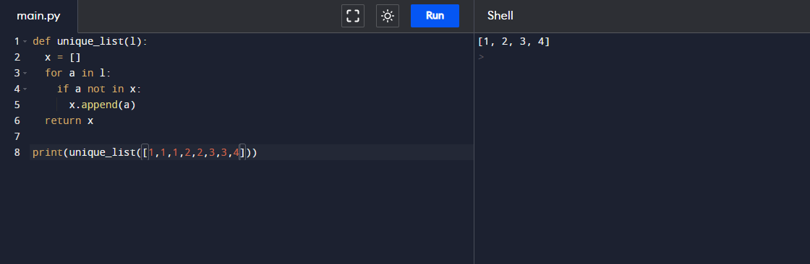

**Practical 9**

**Aim:** Write a python function to multiply all the numbers in the list.

**Output:**

-336

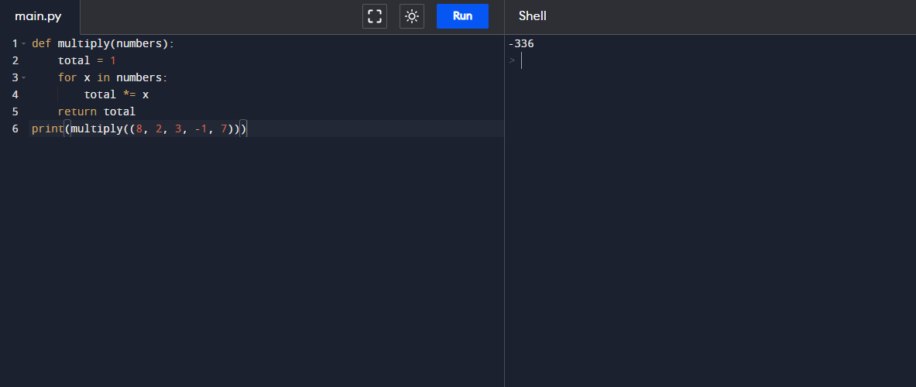

**Practical 10**

**Aim:** Write a program for validating the user input

**Output:**

Enter an integer 1-10: 10

You entered: 10

Enter your password: 12369

You entered 12369

12369

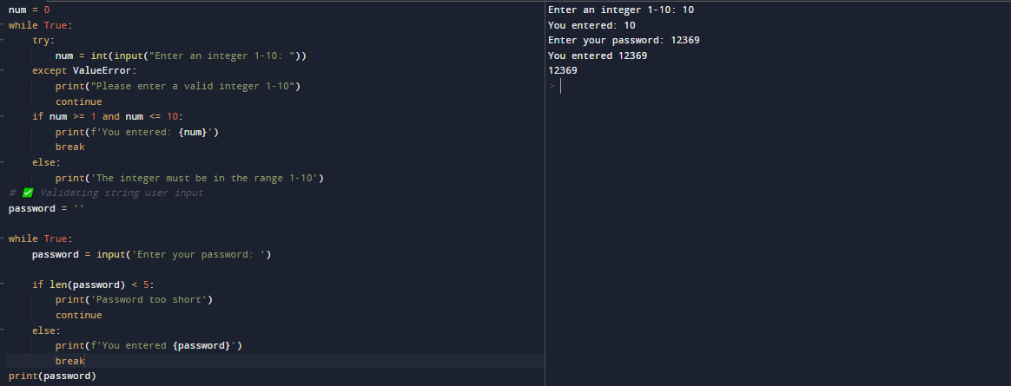

**Practical 11**

**Aim:** Using Object oriented programming, write a program for opening a Bank account, deposit of money and withdrawal of money. Also generate a 4 digit unique code for each transaction.

**Output:**

Account opened successfully!

Account Number: 1234567890

Deposit of $1000.00 successful.

Transaction Code: 2453

Current Balance: $1000.00

Withdrawal of $500.00 successful.

Transaction Code: 2074

Current Balance: $500.00

Insufficient funds!

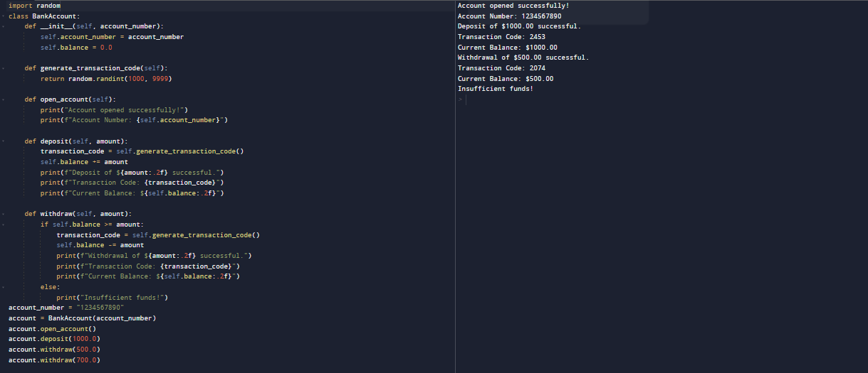

**Practical 12**

**Aim:** Write a program to print next five days starting from Monday.

**Output:**

2023-05-27 18:56:38.213943

2023-05-28 18:56:38.213943

2023-05-29 18:56:38.213943

2023-05-30 18:56:38.213943

2023-05-31 18:56:38.213943

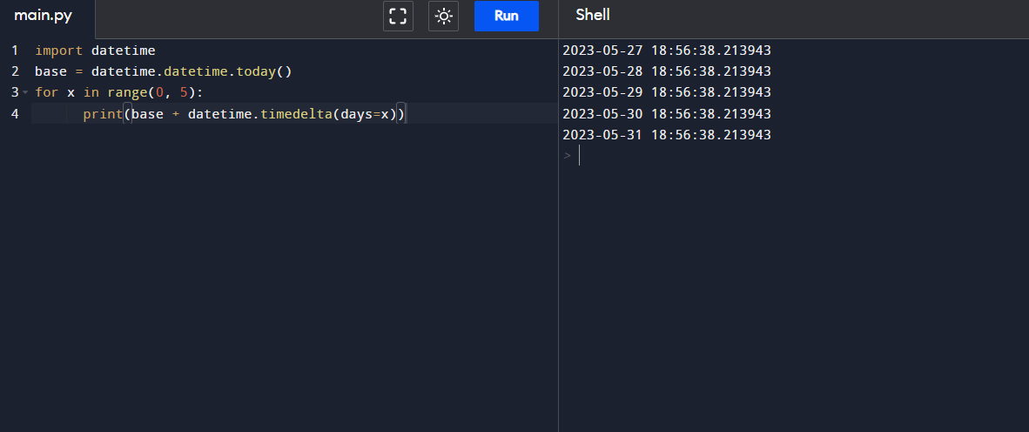

**Practical 13**

**Aim:** Write a function that asks for an integer and prints square of it. Use a while loop with a try, except, else block to account for incorrect inputs.

**Output:**

Enter an integer: a

Invalid input. Please enter an integer.

Enter an integer: 7

The square of 7 is 49.

